**A Project Report**

**on**

**Placement Hub**

**submitted as partial fulfilment for the award of**

**BACHELOR OF TECHNOLOGY**

**DEGREE**

**SESSION 2022-23**

**in**

**INFORMATION TECHNOLOGY**

**By**

**Dev Bhaskar Singh (1900290130053)**

**Divyank Goyal (1900290130060)**

**Under the supervision of**

**Prof. Nitin Kumar**



## Affiliated to

**Dr. A.P.J. Abdul Kalam Technical University, Lucknow**

**(Formerly UPTU)**

# **DECLARATION**

##### We hereby declare that this submission is our own work and that, to the best of our knowledge and belief, it contains no material previously published or written by another person nor material which to a substantial extent has been accepted for the award of any other degree or diploma of the university or other institute of higher learning, except where due acknowledgment has been made in the text.

##### Signature

##### Name: Dev Bhaskar Singh

##### Roll No.: 1900290130053

##### Date: 26/12/2022

##### Signature

##### Name: Divyank Goyal

##### Roll No.: 1900290130060

##### Date: 26/12/2022

# **CERTIFICATE**

##### This is to certify that Project Report entitled “**Placement Hub**” which is submitted by **Dev Bhaskar Singh** and **Divyank Goyal** in partial fulfilment of the requirement for the award of degree B. Tech. in Department of Information Technology of Dr. A.P.J. Abdul Kalam Technical University, Lucknow is a record of the candidates own work carried out by them under my supervision. The matter embodied in this report is original and has not been submitted for the award of any other degree.

##### Date: 26/12/2022 Prof. Nitin Kumar

# **ACKNOWLEDGEMENT**

##### It gives us a great sense of pleasure to present the report of the B. Tech Project undertaken during B. Tech. Final Year. We owe special debt of gratitude to **Prof. Nitin Kumar**, Department of Information Technology, KIET, Ghaziabad, for her constant support and guidance throughout the course of our work. Her sincerity, thoroughness and perseverance have been a constant source of inspiration for us. It is only her cognizant efforts that our endeavors light of the day.

##### We also take the opportunity to acknowledge the contribution of **Dr. Adesh Kumar Pandey**, Head of the Department of Information Technology, Ghaziabad, for his full support and assistance during the development of the project. We also do not like to miss the opportunity to acknowledge the contribution of all the faculty members of the department for their kind assistance and cooperation during the development of our project.

##### We also do not like to miss the opportunity to acknowledge the contribution of all faculty members, especially faculty/industry person/any person, of the department for their kind assistance and cooperation during the development of our project. Last but not the least, we acknowledge our friends for their contribution in the completion of the project.

##### Signature

##### Name: Dev Bhaskar Singh

##### Roll No.: 1900290130053

##### Date: 26/12/2022

##### Signature

##### Name: Divyank Goyal

##### Roll No.: 1900290130060

##### Date: 26/12/2022

# **ABSTRACT**

##### The Project Named “**PLACEMENT HUB**” is a student/company web-based Information system .Training and Placement Cell is the management cell it is supported by databases. Training and Placement has a major role in every college in which most of the work till now is carried out manually. The Main aim of this project is to Automate the Training and Placement procedure in our college. This project reduces manual work and maximum the optimization, abstraction and security. This is a web application which will help students as well as the administration authority to carry out each and every activity in campus hiring.

##### This system is an application that can be accessed throughout the organization and outside as well with proper login credentials. This system can be used as an application for the Training and placement cell of the college to manage the student information with regarding placement recruitment.

##### Students able to view eligibility criteria based on their CGPA for the up-coming placement drives and they can access technical and QA papers regarding particular company.

**TABLE OF CONTENTS**

DECLARATION................................................................................................... ii

CERTIFICATE..................................................................................................... iii

ACKNOWLEDGEMENTS.................................................................................... iv

ABSTRACT......................................................................................................... v

LIST OF FIGURES.............................................................................................. vii

CHAPTER 1 (INTRODUCTION)........................................................................... 1

CHAPTER 2 (LITERATURE REVIEW) ..................................................................12

CHAPTER 3 (PROPOSED METHODOLOGY) ......................................................14

CHAPTER 4 (IMPLEMENTATION AND OUTCOME) ………..................................25

CHAPTER 4 (CONCLUSION AND FUTURE SCOPE) ………………………………………….28

CHAPTER 4 (REFERENCES)…………………………………………………………………………...29

List Of Figures

|  |  |  |
| --- | --- | --- |
| Figure Number | Figure Name | Page Number |
| 3.2 | System Architecture | 6 |
| 3.4.1 | Sequence diagram | 8 |
| 3.4.2 | Component diagram | 9 |
| 3.4.3 | Class diagram | 10 |
| 3.5.1 | Use case diagram | 11 |
| 3.5.2 | State chart diagram | 14 |

# **INTRODUCTION**

##### Our project is mainly focused on analysis and tracking of student Performance in placement drives. To implement this application, coordinator has to collect the student’s data,those who are eligible and qualified for the aptitude and future rounds.

##### The current system is computerized one, but it does not meet the needs of Training and Placement Cell. In existing system, the student’s data is maintained in Excel Sheets. According to the Company’s Requirement the data is short listed manually by the TPO's. Handling and maintaining of student’s data manually is hectic to the T&P Dept and sometimes it might be inaccurate. To overcome these limitations,we proposeda new system called “AN EFFECT OF ERP ON WEB BASED PLACEMENT ANALYSIS AND TRACKING SYSTEM”.

##### The main purpose of this project is to add new features to existing system. The proposed one is an online system which can be accessed throughout the Organization and outside as well with valid login credentials. This system can be used as an application for the Training and Placement Department of the college to manage student’s information regarding Placements. The student’srecord includes personal details, educational qualifications, professional skills and academics,etc.,This system acts as central repository for student information.

# **1.1 Placement Management System**

##### The Placement Management System acts as an interface between campus recruitment cell and students. Here students can get the details by logging into the website. Some circulars regarding ongoing placements which are provided to the students who are going to attend campus placements. This system also provides facility to admin to update details of students and retrieve their data.

# **1.2 Scope of Project:**

##### This project covers wide scope of information of all the students which can be stored in the format of CV’s are categorized according to various streams. Various companies can access the information of students and they can maintain and update their information. Notifications are sent to students about the companies. Students can access previous information regarding.

##### View Student Profile

##### Company Page

##### Company recruitment schedule Page

##### View Recruitment Schedule

##### View Selected List of Students

##### Coordinator page includes ongoing page, process page

##### Upload technical papers

# **1.3 Motivation for the work**

##### In our college T&P department collecting the placements data manually and also they are maintaining student’s data who are qualified for next rounds in the form of excel sheets. So with the help of T&P department we have decided to develop a web based application on training and placements. This project is completely developed by taking the inputs from the TPO.

# **1.4 Problem Statement:**

##### This project is aimed at developing an online application for the Training and Placement Dept. of the college. This system is an online application that can be accessed throughout the organization and outside as well with proper login credentials. This system can be used as an application for the T&P department of the college to manage the student’s information regarding placement. Students can view the companies’ schedules which are going to the college and schedule dates for upcoming company and also they have login ID, username they can

##### change their password without concerned Admin. Coordinator send message to the student about upcoming placement to our college.

# **1.5 Organization of the thesis**

##### The purpose of the introduction chapter is to provide an overview of the entire thesis, summary of the project and its future scope. It also tells about the basic architecture and implementation of the project

##### It contains the methodology of the system, tells about the existing system and our proposed system.

##### It contains the aspects of system analysis and feasibility study which tells about the how much the developed application has met client requirements.

##### It explain about the different modules involved in the system and its basic overview

##### It shows class diagram of the proposal system gives the brief explanation of hardware, software, application requirements of the

##### It contains the various Frameworks implemented in our application

##### It concludes our project work and gives an idea about future scope of the project

# **LITERATURE SURVEY**

##### AlmahdiAlshareef, Ahmed Alkilany basically focuses on providing a simple interface for the easy collation and maintenance of all manner of student information. The creation and management of accurate, up-to- date information regarding students’ academic careers is critical students and for the faculties and administration of Sebha University in Libya and for any other educational institution. A student information system deals with all kinds of data from enrollment to graduation, including program of study, attendance record, payment of fees and examination results to name but a few. All these data need to be made available through an Online Interface [1].

##### Prabhu T Kannan, Srividya K Bansal focuses on providing information to support the operation, management and decision-making functions of enterprises or organizations. In the face of huge amount of information, it is required to possess the student information management system to improve the efficiency of student management. Through this system, the standardized management, scientific statistics and fast query of student information can be realized, and thus the workload of management can be reduced. In this paper, a typical student information management system will be established to realize the systematization, standardization and automation of student information relationship [2].

##### S.R.Bharamagoudar, Geeta R.B, S.G.Totad focuses on simple interface for maintenance of student information. The creation and management of accurate, up-to- date information regarding a student’s academic career is critically important in the university as well as colleges. Student information system deals with all kind of student details, academic related reports, college details, course details, curriculum, batch details, placement details and other resource related details too. It tracks all the details of a student which can be used for all reporting purpose, tracking of attendance, progress in the course, completed semesters, years. Different reports and Queries can be generated based on vast options related to students, batch, course, faculty, exams, semesters, certification and even for the entire college [3].

##### Shiqiu Huang, Rzhang, zhengwei Qi investigated on the Dynamic taint analysis is a prevalent approach to protect a program from malicious behaviors, but fails to provide any information about the code which is not executed. This paper describes a novel approach to overcome the limitation of traditional dynamic taint analysis by integrating static analysis Into the system and presents framework SDCF to detects of ware vulnerabilities with high code coverage. Our experiments show that SDCF is not only able to provide efficient runtime protection by introducing an overhead of 4.16 based on the taint tracing technique, but is also capable of discovering latent software vulnerabilities which have not been exploited , and achieve code coverage of more than 90% [4].

##### Hecio A. Soares and Raimundo S. Moura basically focuses on the users can access easily to this and the data can be retrieved easily in no time. In the student registration form, we can give personal details, educational qualifications, and professional skills and upload resume. The job details of the placed students will be provided by the administrator. The job provider and the placements coordinator to take effective actions on the web as follow-on from the information they have viewed. The administrator plays an important role in our project. He provides approval of student registration and updating [5].

## **2.1 EXISTING SYSTEM:**

##### Existing system does all process has done by manually. Placement officers maintain the information about students manually. If any modifications or updates are required in their profile of any students, it has to be done manually. This is very difficult task for TPO to maintain the student data and company details as it is time consuming, lack of security of data and also it takes more man, etc,. This is so difficult to the Tpo when number of user's increases.

# **METHODOLOGY**

## **3.1 PROPOSED SYSTEM:**

##### The proposed website includes the following features:

##### Training and placement department maintains the details of each student.

##### Students can view the status of their upcoming campus.

##### Search feature helps to admin because they check particular student is present or not

##### Admin can only update student details and academic records like email id, current semester, correspondence address and marks obtained in different semesters via csv file.

##### Provides a proper communication channel between student and training & placement department using the Sms.

##### Latest information about which company is visiting the campus is provided in the website which helps the students to get updated information quickly.

##### Website is user friendly with more GUI so that student view the information easily.

##### Duplicate registrations can be avoided and hence it provides reliability.

##### Only administrator can modify the Placement and organization record if needed.

##### website more helps to make a short list of students who get placed in certain Company and who is unplaced. student can manage passwords, access technical papers and view eligibility criteria for on-going recruitments. Coordinators maintaining the attendance records of CRT classes.

## **3.2 System Architecture**

## **3.3 DESIGN**

##### In designing a new system, the system analyst must have a clear understanding of the objectives, which the design is aiming to fulfill. The first step is to determine how the output is to be produced and in what format. Second, input data and master files have to be designed to meet the requirements of the proposed output. The operational phases are handled through program construction and testing.

##### Design of the system can be defined as a process of applying various techniques and principles for the purpose of defining a device, a process or a system in sufficient detail to permit its physical realization. This system design is a solution to “how to” approach to the creation of a new system. This important phase provides the understanding and the procedural details necessary for implementing the system recommended in the feasibility study. The design step provides a data design, architectural design, and a procedural design

##### **UML DIAGRAMS:**

##### Unified Modelling Language (UML) is a general-purpose modelling language. The main aim of UML is to define a standard way to visualize the way a system has been designed. It is quite similar to blueprints used in other fields of engineering.UML is not a programming language, it is rather a visual language.

##### UML is linked with object-oriented design and analysis. UML makes the use of elements and forms associations between them to form diagrams. Diagrams in UML can be broadly classified as:

##### **Structural Diagrams** – Capture static aspects or structure of a system. Structural Diagrams include: Component Diagrams, Sequence Diagrams, Class Diagrams and Deployment Diagrams.

##### **Behaviour Diagrams** – Capture dynamic aspects or behavior of the system. Behaviour diagrams include: Use Case Diagrams, State Chart Diagrams, Activity Diagrams.

## **3.4 Structural Diagrams:**

##### **Sequence diagram:**

##### This is the Login Sequence Diagram of Placement Cell Management System, where admin will be able to login in their account using their credentials. After login user can manage all the operations on Applicant, Job, Company, College. All the pages such as Company, Attendance, College are secure and user can access these pages after login. The diagram below helps demonstrate how the login page works in a Placement Cell

##### Management System. The various objects in the Qualification Applicant, Job, Company, and College page interact over the course of the sequence, and user will not be able to access this page without verifying their identity.

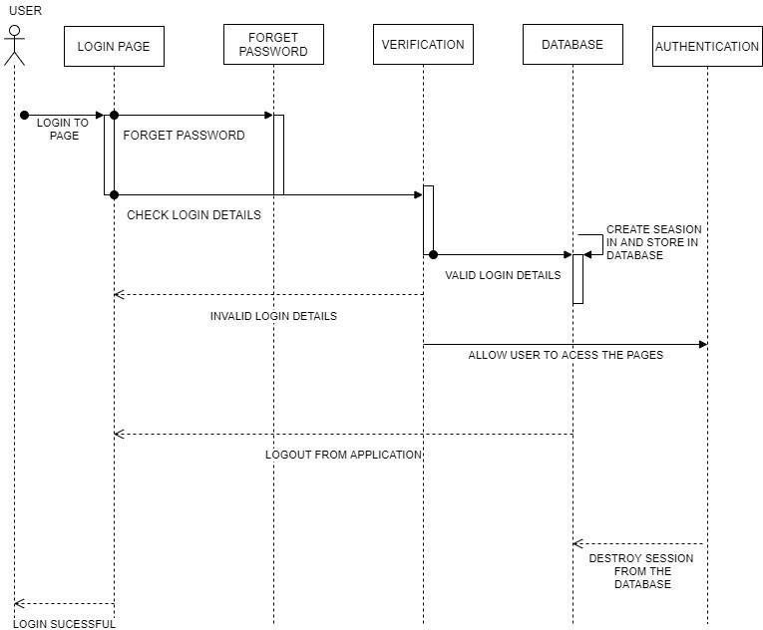

3.4.1 Sequence Diagram

##### **Component Diagram:**

##### This is a Component diagram of Placement Cell Management System which shows components, provided and required interfaces, ports, andrelationships between the Qualification, College, Training Applicants and Job. This type of diagrams is used In Component-Based Development (CBD)to describe systems with Service-Oriented Architecture (SOA). Placement Cell Management System UML component diagram, describes theorganization and wiring of the physical components in a system Components of UML Component Diagram of Placement Cell Management System

##### College Component

##### Training Component

##### Applicant Component

##### Job Component

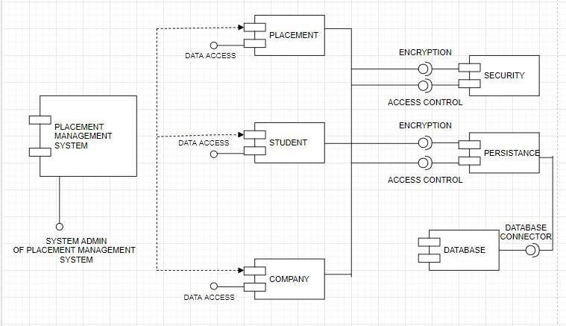

* + 1. Component Diagram

##### **Class Diagram:**

##### Placement Cell Management System Class Diagram describes the structure of a Placement Cell Management System classes, their attributesoperations (or methods), and the relationships among objects. The main classes of the Placement Cell Management System are Placements, Training, Jobs, Company, College, Student.

##### Classes of Placement Cell Management System Class Diagram:

##### Placements Class Manage all the operations of Placements

##### Training Class Manage all the operations of Training

##### Job Class Manage all the operations of Job

##### Company Class Manage all the operations of Company

##### College Class Manage all the operations of College

3.4.3 Component Diagram

## **3.5 Behaviour Diagrams:**

##### **Use case Diagram**

##### This Use Case Diagram is a graphic depiction of the interactions among the elements of Placement Cell Management System. It represents the methodology used in system analysis to identify, clarify and organize system requirements of Placement Cell Management System. The main actors of Placement Cell Management System in this Use Case Diagram are: Admin System User, Company, Attendance, Shortlist, Roles who perform the different type of use cases such as Manage Placements, Manage Training, Manage Job, Manage Company, Manage College,

##### Manage Applicant, Manage Qualification, Manage Users and Full Placement Cell Management System Operations, Major elements of the UML use case diagram of Placement Cell Management System are shown on the picture below.

Coordinator:

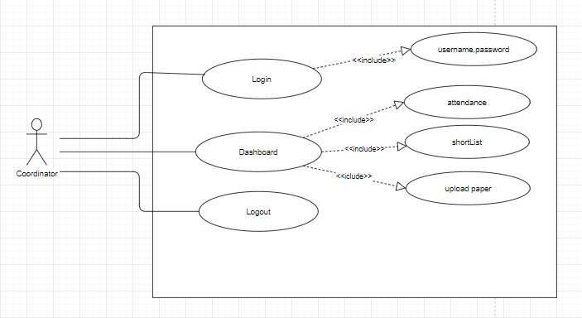

3.5.1 Use case Diagram

Company:

3.5.1 Use case Diagram

Attendence:

3.5.1 Use case Diagram

ShortList:

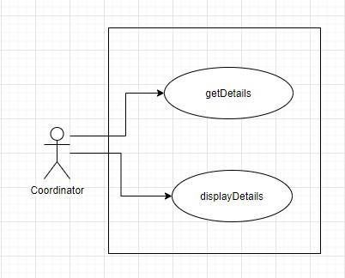

3.5.1 Use case Diagram

##### **State Chart Diagram:**

##### Coordinator:

* + 1. Start Chart Diagram

##### Student:

3.5.2 Start Chart Diagram

# **IMPLEMENTATION AND OUTCOME**

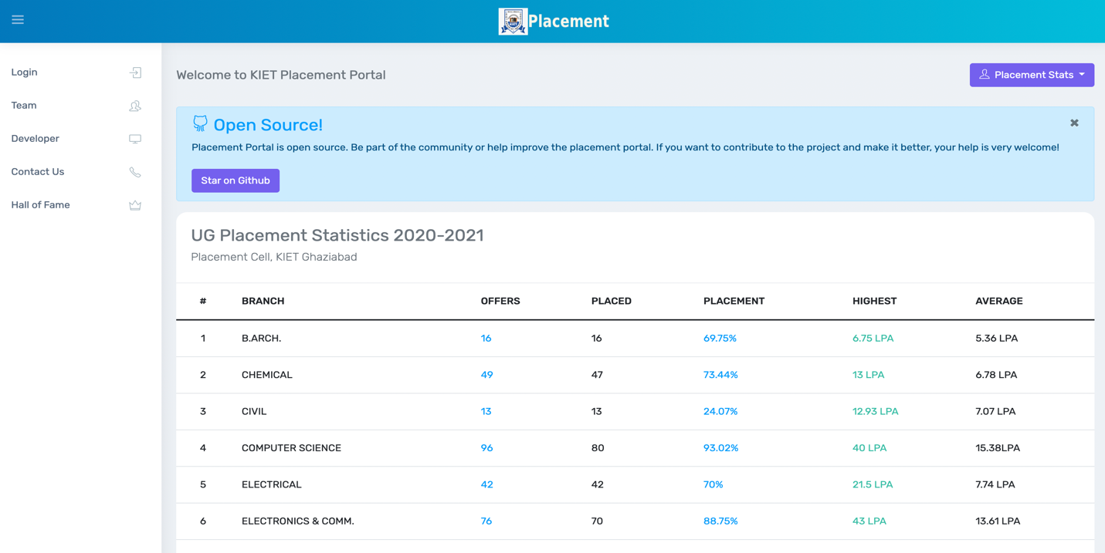

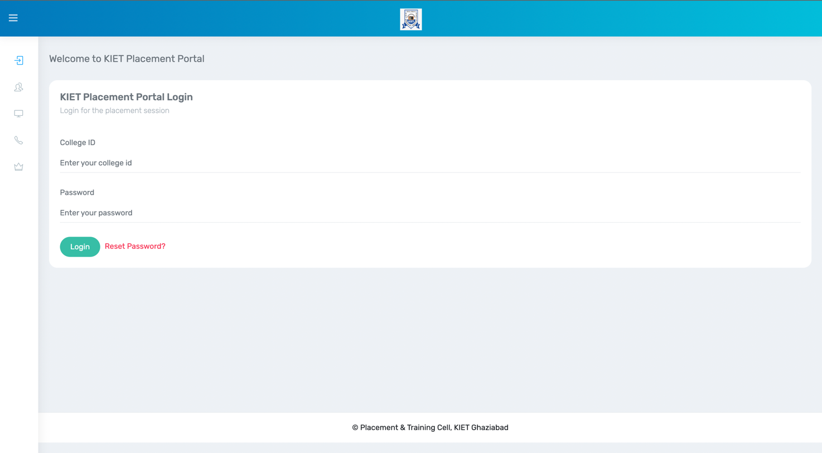

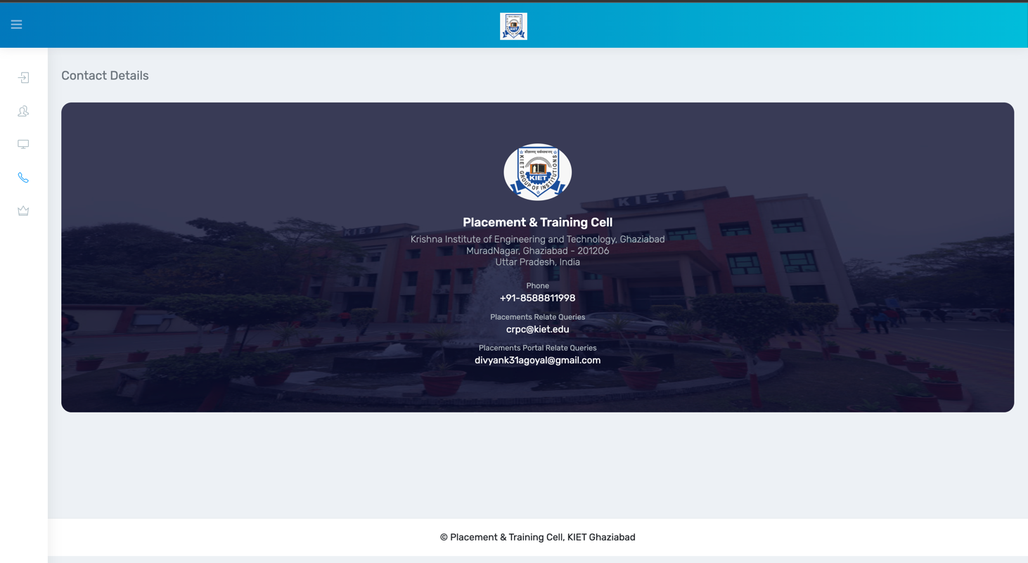

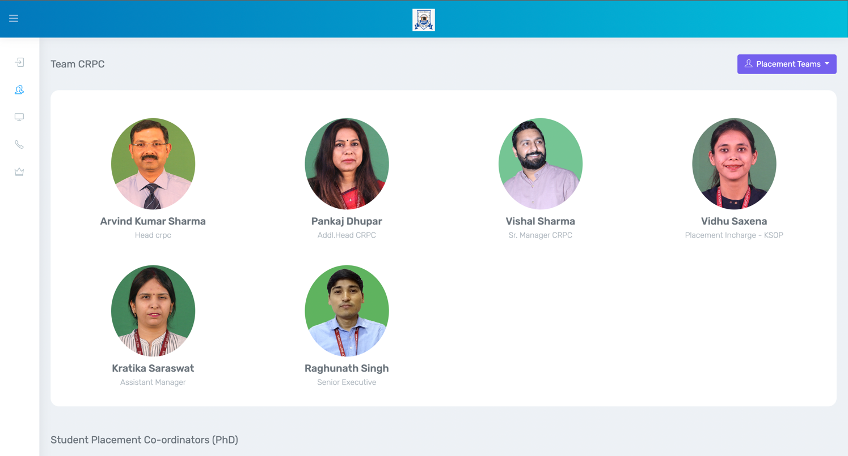

# **Conclusion and Future work**

## **4.1 Conclusion**

##### In the existing system most of the the work will be done manually, as it takes more time for any changes in the system. The major problem with this existing system are notification method available is not available for giving information about student expect the notice board or circulars. The proposed system is online training and placement management system gives the automation in all the process of campus recruitment, searching student details individually. This system in future could be joined to Sms server so that it can notify the message to students via Sms for upcoming companies.

## **4.2 Future work**

##### In future there is a chance to conduct MR after HR in such cases we can change the application according to the requirements.

##### There is a chance to generate graphs on placement procedure on the bases of database.

##### In future there is a scope for staff/coordinators to change their passwords. In future we can add an alert domain for the sake of students.

##### In future we can add a Feedback from student to faculity.

##### In future we can add Company information through company page links.

##### In future we can add Chatbot for clarifying our doubts

.

# **REFERENCES**

1. *M. K. Abd-Ellah, A. I. Awad, A. A. M. Khalaf, and H. F. A. Hamed, ‘A review on brain tumor diagnosis from MRI images: Practical implications, key achievements, and lessons learned’, Magn. Reson. Imaging, vol. 61, no. May, pp. 300–318, Sep. 2019, doi: 10.1016/j.mri.2019.05.028.*
2. *K. R. Bhatele and S. S. Bhadauria, ‘Brain structural disorders detection and classification approaches: a review’, Artif.Intell. Rev., 2019, doi: 10.1007/s10462-019-09766-9.*
3. *D. Nanware, S. Taras, and S. Navale, ‘Brain Tumor Detection Using Deep Learning’, Int. J. Sci. Res. Eng. Dev., vol. 3,pp. 391–395, 2020.*
4. *Muhmmad Irfan Sharif, ‘Recent Advancements in Brain Tumor Segmentation and Classification using Deep Learning: A Review’, Int. J. Eng. Res., vol. V8, no. 12, pp. 319–325, 2019, doi: 10.17577/ijertv8is120190.*
5. *H. Kaur and A. K. Gill, ‘Review of Brain Tumor Detection Using Various Techniques’, Int. J. Adv. Res. Comput. Sci. Softw. Eng., vol. 7, no. 5, pp. 867–870, 2017, doi: 10.23956/ijarcsse/v7i4/0221.*
6. *M. Sharif, J. Amin, M. Raza, M. Yasmin, and S. C. Satapathy, ‘An integrated design of particle swarm optimization (PSO) with fusion of features for detection of brain tumor’, Pattern Recognit. Lett., vol. 129, pp. 150–157, Jan. 2020,doi: 10.1016/j.patrec.2019.11.017.*
7. *M. Jayali, V. Bhagat, and B. Dhaigude, ‘A Survey on Brain tumor Detection Techniques’, Int. Res. J. Eng. Technol., vol.8, no. 4, pp. 28–32, 2017.*
8. *M. I. Sharif, J. P. Li, J. Naz, and I. Rashid, ‘A comprehensive review on multi-organs tumor detection based on machine* learning’, Pattern Recognit. Lett., vol. 131, pp. 30–37, Mar. 2020, doi: 10.1016/j.patrec.2019.12.006.
9. *B. Panda and C. S. Panda, ‘A Review on Brain Tumor Classification Methodologies’, Int. J. Sci. Res. Sci. Technol., vol.6, no. 6, pp. 346–359, 2019, doi: 10.32628/ijsrst20717.*
10. *R. Kaur and A. Doegar, ‘Localization and Classification of Brain Tumor using Machine Learning &amp; Deep Learning Techniques’, Int. J. Innov. Technol. Explor. Eng., vol. 8, no. 9S, pp. 59–66, Aug. 2019, doi: 10.35940/ijitee.I1010.0789S19.*
11. *M. Nazir, M. A. Khan, T. Saba, and A. Rehman, ‘Brain tumor detection from MRI images using multi- level wavelets’,* 2019 Int. Conf. Comput. Inf. Sci. ICCIS 2019, pp. 1–5, 2019, doi: 10.1109/ICCISci.2019.8716413.
12. *R. L. Siegel, K. D. Miller, and A. Jemal, ‘Cancer statistics, 2020’, CA. Cancer J. Clin., vol. 70, no. 1, pp. 7–30, Jan.2020, doi: 10.3322/caac.21590.*
13. *A. M. Sarhan, ‘Brain Tumor Classification in Magnetic Resonance Images Using Deep Learning and Wavelet Transform’, J. Biomed. Sci. Eng., vol. 13, no. 06, pp. 102–112, 2020, doi: 10.4236/jbise.2020.136010.*
14. *M. Mudda, R. Manjunath, and N. Krishnamurthy, ‘Brain Tumor Classification Using Enhanced Statistical Texture Features’, IETE J. Res., vol. 0, no. 0, pp. 1–12, 2020, doi: 10.1080/03772063.2020.1775501.*
15. *S. A. Swapnil and V. S. Girish, ‘Image Mining Methodology for Detection of Brain Tumor: A Review’, in 2020 Fourth International Conference on Computing Methodologies and Communication (ICCMC), 2020, no. Iccmc, pp. 232–237, doi: 10.1109/ICCMC48092.2020.ICCMC-00044.*
16. *L. Kapoor and S. Thakur, ‘A survey on brain tumor detection using image processing techniques’, in 2017 7th International Conference on Cloud Computing, Data Science & Engineering - Confluence, 2017, pp. 582–585, doi:10.1109/CONFLUENCE.2017.7943218.*

# 